**Question 2:** Verify that the solutions do actually existing in the Toronto plan. I'd start with keyword/phrases searches using the text from the CSV against the PDF. When you do find the example of the solution, note the page number and maybe give it a 1-3 rating of how accurate the result was. You only have to do this for one of the results CSVs

**Question 2:** Assessment of how closely the solutions extracted from the CSV align with the Toronto Resilience Strategy, along with a rating based on the level of explicit match between the strategy document and the tool’s output.

[solutions - query matching](https://docs.google.com/spreadsheets/d/17kgqqoUBBffHkB765rq22Vho_XuaTfo_lu-EAYXvBBY/edit?usp=sharing)

<https://docs.google.com/spreadsheets/d/17kgqqoUBBffHkB765rq22Vho_XuaTfo_lu-EAYXvBBY/edit?usp=sharing>

Zotero project: <https://www.zotero.org/groups/5730847/toronto/items/IZU9BFP8/reader>

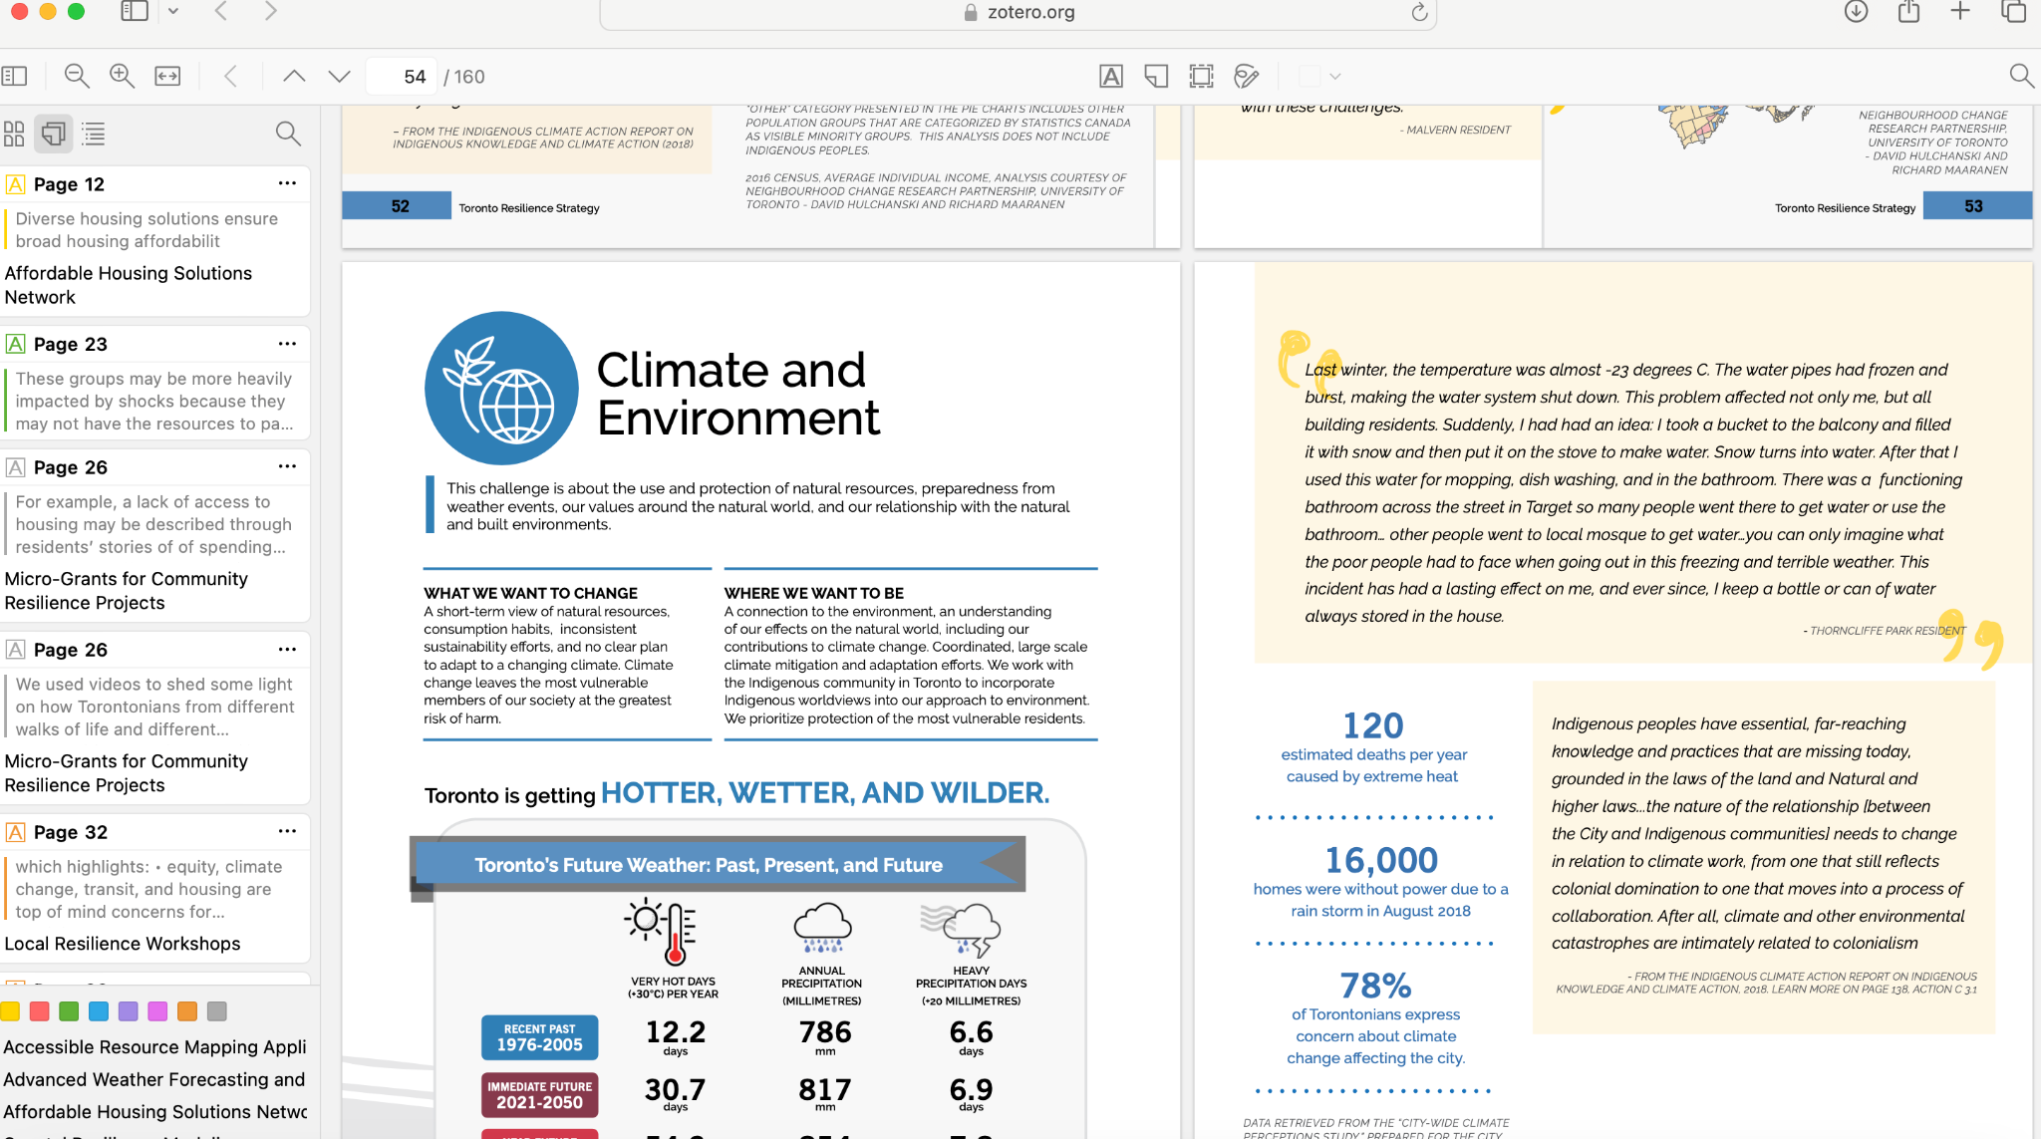

To summarize the "solutions-final.csv" dataset with a focus on "best-matched" solutions, here’s an analysis:

1. Best-Matched Solutions:

- Solutions with the highest alignment to the Toronto Resilience Strategy were rated 3/3. These include:

- "Resilient Coastal Infrastructure" (Page 95): A highly aligned solution focusing on coastal protection through infrastructure and real-time monitoring.

- "Community Engagement Platforms" (Pages 84, 129): Includes multiple initiatives for enhancing community-driven resilience engagement.

- "Wildfire Risk Assessment Tools" (Page 149): Utilizes data analytics and satellite imagery for proactive wildfire risk management.

2. Partial Matches:

- Some solutions received a 2/3 rating, indicating partial alignment with strategy content. For example:

- "Snow and Ice Management Technologies" (Page 98): Mentioned in general maintenance and winter resilience sections but lacks specific technology details.

- "Resilient Housing Initiatives through Smart Building Technology" (Pages 120, 140): Discussed under resilient housing upgrades, though specific smart technology is not emphasized.

3. Not Mentioned Solutions:

- Approximately 39.4% of solutions were either partially or entirely missing from the strategy document. Examples include:

- "Wildfire Risk Mitigation Technology" and "Infectious Disease Surveillance Systems" – both solutions address critical areas but were not directly referenced in the strategy.

4. Summary:

- The dataset illustrates a broad overlap with the strategy, though some high-priority technologies, especially related to specific climate threats like infectious disease monitoring, were not explicitly covered. Solutions that align closely with the strategy (rated 3/3) reflect the strategy’s focus on community resilience, coastal infrastructure, and emergency response.

https://docs.google.com/presentation/d/1sh-AgCCCEP1Na7yytaLjJr8WRdEgT8a0HoV9QNdWlog/edit?usp=sharing